EMOTIONAL ANALYSIS USING DEEP LEARNING

Mr. Jigar Patel¹, Kanumuri Swetha², BRL. Suchandana ³, Ch. Chandana Sahithi ⁴

¹Assistant Professor, Department of Electronics and Communication Engineering,

B. V. Raju Institute of Technology, Narsapur, Medak, Telangana, India.

^{2,3,4}Final Year students, Department of Electronics and Communication Engineering,

B. V. Raju Institute of Technology, Narsapur, Medak, Telangana, India.

¹jigar.patel@bvrit.ac.in
²18211a04a2@bvrit.ac.in
³18211a0439@bvrit.ac.in
⁴18211a0442@bvrit.ac.in

ABSTRACT

Human emotions are mental states of sentiments that emerge without conscious effort and occur in the midst of physiological changes in facial muscles that result in facial expressions. Examples embody happiness, sadness, anger, disgust, fear, surprise, and different necessary emotions. As a result of they convey a personality's inner feelings, facial expressions play a vital role in nonverbal communication. an incredible heap of analysis has gone into laptop modelling of human feeling. It is, however, still an extended method from the human sensory system. varied makes an attempt are created to beat restrictions and build new opportunities, yet on higher perceive and implement this straightforward technique of human interaction in our computer-dominated world. New strategies for aggregation facial expressions are used, alongside fast, high-resolution image capture, to help America appraise and interpret authentic face emotions in real time. within the lack of motion info, the present FER approach depends on static frames, that makes it not possible to spot foreground from background clusters. With gift systems, the Facial Emotion Recognition in video motion in order to overcome this drawback. This study offers a period of time facial features identification approach supported HAAR cascading classification and Convolutional Neural Networks for expression categorization. This model uses the camera on the device to dynamically show the feeling as text. We were able to classify seven basic human emotions, including disgust, fear, happy, sad, surprise, angry, and neutral, with a 62% nothing accuracy rate on check information. recognizing facial characteristics will be helpful during a form of period of time applications, together with airfield security, trading, patient watching, and so on.

Keywords: Emotion Recognition, HAAR, Facial Expressions, Convolutional Neural Network.

INTRODUCTION

Emotions square measure accustomed to communicate and execute social connections. it is a nonverbal quite communication that, like visual communication, might create a spoken communication a lot of fascinating. The seven universal emotions recognised by varied civilizations square measure happy, surprise, neutral, anger, sad, fear, and disgust. amazingly, society discussions should still be found once coping with a lot of difficult assertions which will be expressed in many ways that. As a result, if a technology for recognizing feeling from facial expressions were offered, these disparities would be resolved.

This form of innovation would be a lot of advantageous in terms of security, amusement, and feedback. because of the subsequent restrictions, distinctive facial emotions is a lot of difficult:
1. A dataset which will be accustomed to train the algorithmic program isn't offered.
2. A transition frame into a facial expression or a static image will be used because the input image. employing a camera, a video stream was fed into the CNN model. It's harder thanks to the system's requirement.

In order for the model to control properly, the network should be optimized. It gets more difficult because of the encompassing factors which will have an influence on accuracy. Convolutional Neural Networks are shown to be more practical than different sorts of neural networks. A layer-wise algorithmic program is CNN. it's convolutional layers, every of that is responsible of onanism options within the pictures from the coaching set. Extracted options square measure max pooled to realize shift variance. The elaborateness will increase as you progress from one layer to ensuing. The metaphorical properties of the thing the convolutional filters in the uppermost convolutional layer reflect each other. The outputs of various filters from convolutional layers are classified using layers that are completely related.

Because of its numerous applications in the domains of computer vision, robotics, and human-computer interaction, Facial Emotion Recognition has become a major study topic in recent years. In recent years, Human-Computer Interaction, or FER, has risen in importance as a research field. CNN was able to identify human emotions from dynamic facial expressions in real time with a check accuracy of 57 %, illustrating the utility of deploying neural networks in real time to research human mood. [1]. It is common to detect emotions using voice and graphics record waves. A graph record is used to assess the electrical activity of neurons in the brain. A lot of attention has been paid to speech recognition in a variety of languages. It's one of the elements that encompasses a strong emotional connection. Only a small amount of analysis combining speech, emotion, and EEG has been completed. [2]. When it comes to facial expressions of emotion, there is a lot of agreement across cultures. [3]. code engineering, web site customization, education, and gaming, yet as medical, marketing, and amusement, might all like feeling recognition. There square measure a handful more difficult challenges to beat. The preciseness of the feeling recognition technique is sometimes not glad within the actual world.[4]. Sentiment analysis has been one of the most sought-after services in a number of businesses in recent years, as it assists within the analysis of services, product quality, and market performance. As a consequence of enhancements in net technology, the approach of sentiment analysis has big a lot of economical in each space.

Machine learning algorithms accustomed to predict Alzheimer’s development in patients have a high level of accuracy. Neural networks square measure accustomed to investigate cervical cancer risk factors and stages. IVF to predict embryo sterility from blastula photos, And Diabetic retinopathy identification with an accuracy of quite 87% [5,6,7,8].

2. METHOD

The Kaggle Facial Emotion Recognition competition's FER2013 dataset was used to create the Facial Emotion Recognition system [6]. The dataset contains 35,887 tagged photos, divided into 28709 train images and 3589 test images.
The dataset, including 3589 personal test pictures, was accustomed to conduct the challenge's final check. The black-and-white images within the FER2013 assortment square measure 48x48 pixels in size. The angle, lighting, and scale of the photographs within the FER2013 assortment varies. 0 indicates to angry, 1 indicates to disgust, 2 indicates to fear, 3 indicates to happy, 4 indicates to neutral, 5 indicates to sad, and 6 indicates to surprise. The amount of pictures with varied emotions square measure as seen in table 1.
Figure 1

Images of various emotions from a dataset.

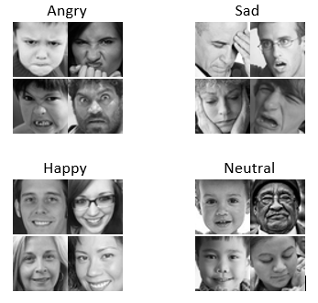

Table 1

shows the number of images with various emotions.

Label | Number of Images | Emotions
0 | 4593 | Angry
1 | 547 | Disgust
2 | 5121 | Fear
3 | 8989 | Happy
4 | 6198 | Neutral
5 | 6077 | Sad
6 | 4002 | Surprise

There are three separate sets in the dataset: Training, private testing, public testing are the three sorts of tests. The Training and Public Tests are used to construct the model, while the Private Test is used to assess it. Figure 1 shows pictures of various emotions from a dataset.

3. IMAGE PREPROCESSING

In the FER system's input picture, there may be differences in lighting, size, and color. To make the algorithm's findings more accurate and faster, some image pre-processing was done.

The preprocessing processes used include grayscale conversion, normalization, and scaling of the image.

1. Normalization - a picture is normalized to scale back lighting variations and improve the looks of the face.

2. Gray scaling – It is frequently used for extracting descriptors as opposed to running on color pics without delay is that grayscale simplifies the set of rules and decreases computational requirements.

3. Resizing - Cut out the parts of the image that are not needed. It also minimizes the amount of memory required and improves computing performance.

4. FACE DETECTION

In every FER system, the initial stage is to detect the face. The HAAR method [7] was used to detect the target. The Viola-Jones detectors, also known as the HAAR cascades classifier technique, are classifiers that are taught to recognize an item in an image or video. They are taught to distinguish between good and negative face pictures. HAAR cascades have shown to be a reliable and fast method of detecting objects in photos. The HAAR features identify three dark spots on the face, such as the eyebrows. The computer is then trained to recognize two dark patches on the face, the location of which is established by rapid pixel computing, which successfully removes unnecessary background data from the image, and the face region is detected by the HAAR cascades.

HAAR cascade classifiers were used to create this facial recognition method in OpenCV. Rectangular attributes were used in this manner in the beginning [8]. Component values between 0 and 1 are calculated using the image's intensity. The darker zone's component values are deducted from the lighter zone's component values. The closer the number is to 1, the more likely a HAAR trait has been discovered. The different types of features are shown in figure-2 and our proposed model architecture shown in figure-3.

Figure 2

Different types of features.

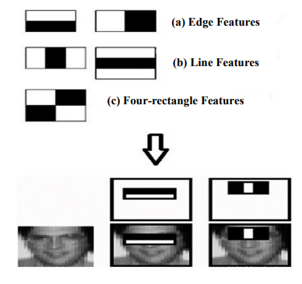

Figure 3

Architecture of proposed model.

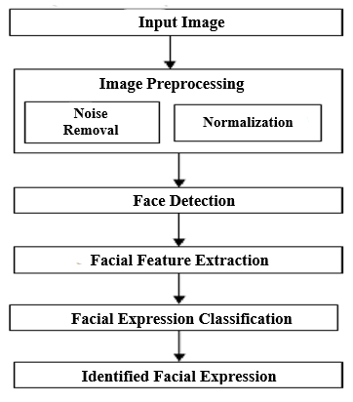

5. EMOTION CLASSIFICATION

The fundamental purpose of the method became to strive out extraordinary architectures at the CNN so that you can enhance accuracy with the validation set at the same time as fending off overfitting. The following are the stairs concerned with inside the feeling category method:

5.1 Data Segmentation
Our dataset is categorized into three uses based on the "Usage" label: coaching, public check, and personal check. The coaching and public check sets were used to create the model, while the private check set was used to evaluate it.

5.2 Model creation and training
In the design of a neural network, there square measure the subsequent layers:
- Layer of Convolution - This method is based on the dot product between the filter and each input native space. The result is a feature map that is a 3D volume of the various filters.

- Pooling at its maximum - Grouping of layers is used to reduce the spatial size of input layers, which reduces input and processing costs.

- Fully connected layer - The variety of classes into which the enter might be looked after determines the scale of the very last output layer.

- Activation function - This was due to the fact that it was not differentiable at zero degrees. Differentiable functions like sigmoid and tanh were commonly used by researchers. ReLU, on the other hand, was recently discovered to be the most effective activation function for deep learning.

f(x) = max(0, x) ---------(1)

ReLU provides the gradient without the need for any calculations. This is extremely useful during back-propagation, since it saves a significant amount of time and processing power. Because most real-time data isn't linear in nature, it's critical for neural networks to integrate non-linearity in their layers. For x>0, ReLU has a linear function, hence there is no saturation.

- Softmax - The softmax function reduces a vector of K real values to a vector of K real values that add up to 1. The softmax translates input values that are positive, negative, zero, or higher than one into values between 0 and 1, allowing them to be understood as probabilities.

$σ{\left(\vec{z}\right)}_{i}=\frac{ⅇ^{z_{i}}}{\sum_{j=1}^{K}{e^{z_{j}}}}$-------(2)

$\vec{z}$ = Input vector
$σ$ = Softmax
$K$ = The multi-class classifier's number of classes.
$ⅇ^{z_{i}}$ = For the input vector, use the standard exponential function.
$e^{z_{j}}$ = For the output vector, use a standard exponential function.

- Batch Normalization - Batch normalization improves the training process's speed. The average activation is kept close to zero, and the standard deviation is kept near to 1.

- These include element values ranging from 0 to 1 based on the image's intensity. The darker zone's element values are deducted from the brighter zone's element values. The closer the number is to one, the more likely a HAAR feature has been discovered.

EVALUATION OF MODEL

The testing set, which contains 3589 images, was used to test the model created during the training phase.

A model for classifying real-time photos has been developed

The concept of transfer learning is used to discern feelings in real-time images. The weights and values determined during the coaching part are used to create a substitute countenance detection challenge. Because the generated model already includes weights, Facial Expression Recognition becomes faster for period photographs. Figure 4 shows the model's convolution style.

Figure 4

Convolutional Architecture of the Model.

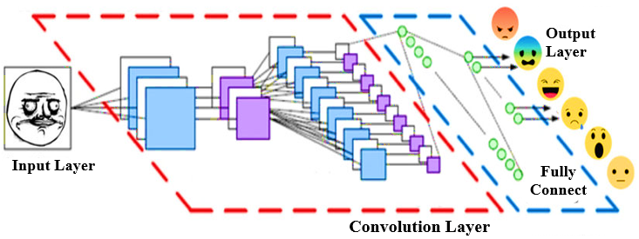

RESULTS

To see if our image preprocessing truly resulted in a more robust model, we tested it on a test set made up of photos from the original dataset, as well as the image data obtained from the camera. In both cases, we found that our validation data-set was properly predicted. Over the course of 50 system epochs, the performance metrics graph shows changes in four separate parameters. The loss training and testing, as well as the accuracy of training and testing, are depicted in Figure 5. Our model's expected outcomes are depicted in Figure 6. When our model is compared to other models, it is discovered that our suggested model accurately predicts emotions better than other models. Figure 7 depicts the comparison graph. Our model's validation accuracy is 62 %.

Figure 5

Loss and Accuracy Graphs.

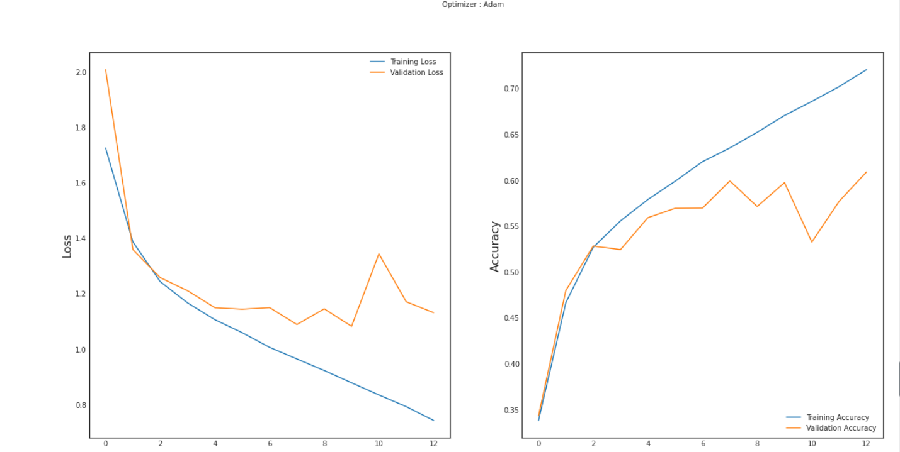

Figure 6

Images of Different emotions.

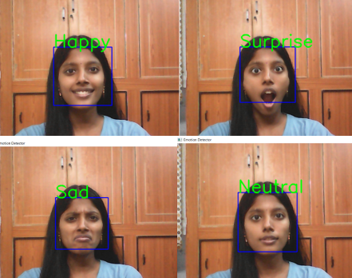
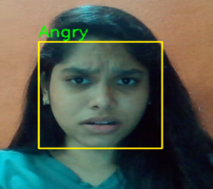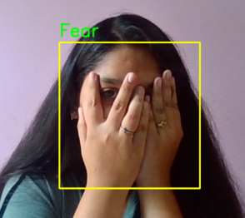

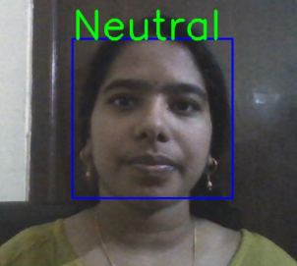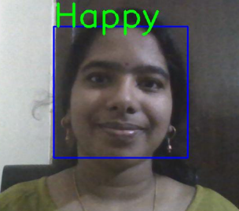

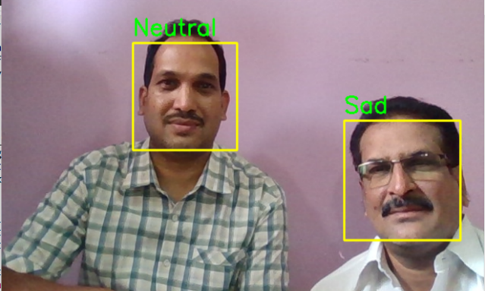

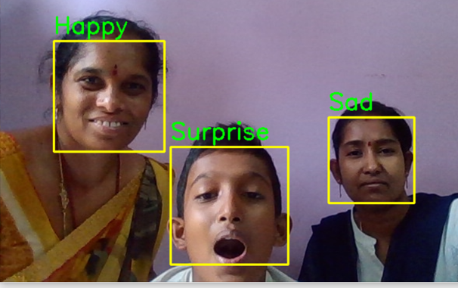

Figure 7

Comparison Graph.

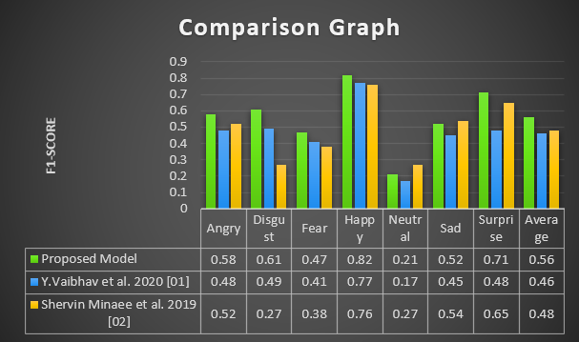

Our model's confusion matrix is more accurate at predicting pleasant, neuronal emotions and less good at predicting disgust and rage. Figure 8 shows our model's confusion matrix, and table 2 shows the classification report.

Figure 8

The proposed model's confusion matrix.

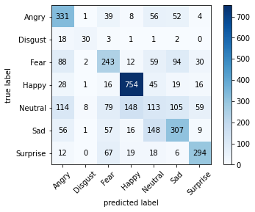

Table 2

Report on Classification.

Emotions | Precision | Recall | F1 Score
Angry | 0.51 | 0.67 | 0.58
Disgust | 0.70 | 0.55 | 0.61
Fear | 0.48 | 0.46 | 0.47
Happy | 0.79 | 0.86 | 0.82
Neutral | 0.26 | 0.18 | 0.21
Sad | 0.52 | 0.52 | 0.52
Surprise | 0.71 | 0.71 | 0.71
- The average precision percentage is 56%.
- The average recall percentage is 58%.
- The average f1-score percentage is 56%.

CONCLUSION

Using a webcam in the system, our algorithm predicts a person's feeling in real time. this can be accomplished by utilizing the CNN rule to create the model. The validation accuracy was found to be 70%, that is larger than existing system accuracy criteria. The model recognized distinct faces in the image and displayed the resulting emotion on the face in matter format, coupled with the text and any of the seven widely recognized emotions such as happy, neutral, angry, surprised, sad, disgust, and fear. It took a long time to form because, unlike previous systems that depended on static images, this one was completely dynamic. The accuracy of the output varied widely depending on lighting circumstances and camera level, and it frequently deviated from the accuracy. Furthermore, locating an appropriate dataset proved to be difficult. The huge dataset was required to train the model and achieve cost-effective accuracy.

When a model predicts an emotion inaccurately, the correct label is often the second most likely emotion. The facial expression recognition system developed for this study develops a powerful face recognition model by mapping behavioral characteristics to physiological biometric data. The physiological components of the human face that are associated to emotions like happy, fear, sad, angry, disgust, neutral, and surprise are linked to geometrical structures that serve as the recognition system's basic matching template.

9. REFERENCE

1. Bhadana L, Lakshmi PV, Krishna DR, Bharti GS, Vaibhav Y. Real Time Facial Emotion Recognition With Deep Convolutional Neural Network. Journal Of Critical Reviews. 2020;7(19).

2. Minaee S, Minaei M, Abdolrashidi A. Deep-emotion: face expression recognition mistreatment basic cognitive process convolutional network. Sensors. 2021 Jan;21(9):3046.

3. Kaviya P, Arumugaprakash T. cluster facial feeling analysis system mistreatment convolutional neural network. In2020 fourth International Conference on Trends in physics and information science (ICOEI)(48184) 2020 Jun 15 (pp. 643-647). IEEE.

4. Kaviya P, Arumugaprakash T. Group facial emotion analysis system using convolutional neural network. In2020 4th International Conference on Trends in Electronics and Informatics (ICOEI)(48184) 2020 Jun 15 (pp. 643-647). IEEE.

5. Lasri I, Solh AR, El Belkacemi M. Facial feeling recognition of scholars mistreatment convolutional neural network. In 2019 third international conference on intelligent computing in knowledge sciences (ICDS) 2019 Gregorian calendar month 28 (pp. 1-6). IEEE.

6. Kumar GR, Kumar RK, Sanyal G. Facial feeling analysis mistreatment deep convolution neural network. In 2017 International Conference on Signal process and Communication (ICSPC) 2017 Jul 28 (pp. 369-374). IEEE.

7. Ouyang X, Zhou P, Li CH, Liu L. Sentiment analysis mistreatment convolutional neural network. In2015 IEEE international conference on pc and data technology; present computing and communications; dependable, involuntary and secure computing; pervasive intelligence and computing 2015 Gregorian calendar month 26 (pp. 2359-2364). IEEE.

8. Jaiswal A, Raju AK, Deb S. Facial feeling detection mistreatment deep learning. In2020 International Conference for rising Technology (INCET) 2020 Jun 5 (pp. 1-5). IEEE.

9. Sariyanidi E, Gunes H, Cavallaro A. Automatic analysis of facial affect: A survey of registration, illustration, and recognition. IEEE transactions on pattern analysis and machine intelligence. 2014 Gregorian calendar month 30;37(6):1113-33.

10. Santamaria-Granados L, Munoz-Organero M, Ramirez-Gonzalez G, Abdulhay E, Arunkumar Garden State. mistreatment deep convolutional neural network for feeling detection on a physiological signals dataset (AMIGOS). IEEE Access. 2018 Gregorian calendar month 23;7:57-67.

11. Rouast PV, Adam MT, Chiong R. Deep learning for human have an effect on recognition: Insights and new developments. IEEE Transactions on affectional Computing. 2019 Jan 1;12(2):524-43.

12. Zhi R, Flierl M, Ruan Q, Kleijn WB. Graph-preserving thin plus matrix factoring with application to face expression recognition. IEEE Transactions on Systems, Man, and information science, part B (Cybernetics). 2010 Apr 15;41(1):38-52.

13. Mellouk W, Handouzi W. Facial feeling recognition mistreatment deep learning: review and insights. Procedia engineering. 2020 Jan 1;175:689-94.

14. Ekman P, Keltner D. Universal facial expressions of feeling. Segerstrale U, P. Molnar P, eds. Nonverbal communication: wherever nature meets culture. 1997;27:46.

15. Tian YI, Kanade T, Cohn JF. Recognizing action units for face expression analysis. IEEE Transactions on pattern analysis and machine intelligence. 2001 Feb;23(2):97-115.

16. Jeong M, Ko BC. Driver’s facial expression recognition in real-time for safe driving. Sensors. 2018 Dec;18(12):4270.

17. Kumar SV, Choi J. Deep Learning Neural spec for Human face expression Recognition. In International Conference on Intelligent and Fuzzy Systems 2021 Aug 24 (pp. 290-297). Springer, Cham.

18. Sekaran SA, Lee CP, Lim KM. Facial feeling recognition mistreatment transfer learning of AlexNet. In2021 ninth International Conference on info and Communication Technology (ICoICT) 2021 Aug three (pp. 170-174). IEEE.

19. Dahmane M, Meunier J. feeling recognition mistreatment dynamic grid-based HoG options. In2011 IEEE International Conference on Automatic Face & Gesture Recognition (FG) 2011 Mar 21 (pp. 884-888). IEEE.

20. Li S, Deng W. Deep facial expression recognition: A survey. IEEE transactions on affective computing. 2020 Mar 17.

21. Shan C, Gong S, McOwan PW. face expression recognition supported native binary patterns: A comprehensive study. Image and vision Computing. 2009 may 4;27(6):803-16.

22. Liu P, Han S, Meng Z, Tong Y. face expression recognition via a boosted deep belief network. In Proceedings of the IEEE conference on pc vision and pattern recognition 2014 (pp. 1805-1812).

23. Mollahosseini A, Chan D, Mahoor MH. Going deeper in face expression recognition mistreatment deep neural networks. In2016 IEEE Winter conference on applications of pc vision (WACV) 2016 Mar 7 (pp. 1-10). IEEE.
24. Zhao G, Pietikainen M. Dynamic texture recognition mistreatment native binary patterns with Associate in Nursing application to facial expressions. IEEE transactions on pattern analysis and machine intelligence. 2007 Apr 23;29(6):915-28.

25. Jung H, Lee S, Yim J, Park S, Kim J. Joint fine-tuning in deep neural networks for face expression recognition. In Proceedings of the IEEE international conference on pc vision 2015 (pp. 2983-2991).

26. Zhao X, Liang X, Liu L, Li T, Han Y, Vasconcelos N, Yan S. Peak-piloted deep network for face expression recognition. In European conference on pc vision 2016 oct 8 (pp. 425-442). Springer, Cham.

27. Zhao JJ, Ma RL, Zhang XL. Speech feeling recognition supported call tree and improved SVM mixed model. Peking Ligong Daxue Xuebao/Transaction of Peking Institute of Technology. 2017 Apr 1;37(4):386-90.

28. Elgarrai Z, Meslouhi OE, Kardouchi M, Allali H. sturdy face expression recognition system supported hidden Andrei Markov models. International Journal of multimedia system info Retrieval. 2016 Nov;5(4):229-36.

29. Pantic M, Valstar M, Rademaker R, Maat L. Web-based information for face expression analysis. In2005 IEEE international conference on multimedia system and accumulation 2005 Jul 6 (pp. 5-pp). IEEE.

30. Zhi R, Flierl M, Ruan Q, Kleijn WB. Graph-preserving thin plus matrix factoring with application to face expression recognition. IEEE Transactions on Systems, Man, and information science, part B (Cybernetics). 2010 Apr 15;41(1):38-52.

